Home Assignment 1:
Explore the templates available in n8n and pick one use case and try to build that flow

Template: https://n8n.io/workflows/11867-extract-transcripts-from-external-youtube-videos-using-youtube-transcript-api/
Usecase - Extract transcripts from external YouTube videos using YouTube Transcript API
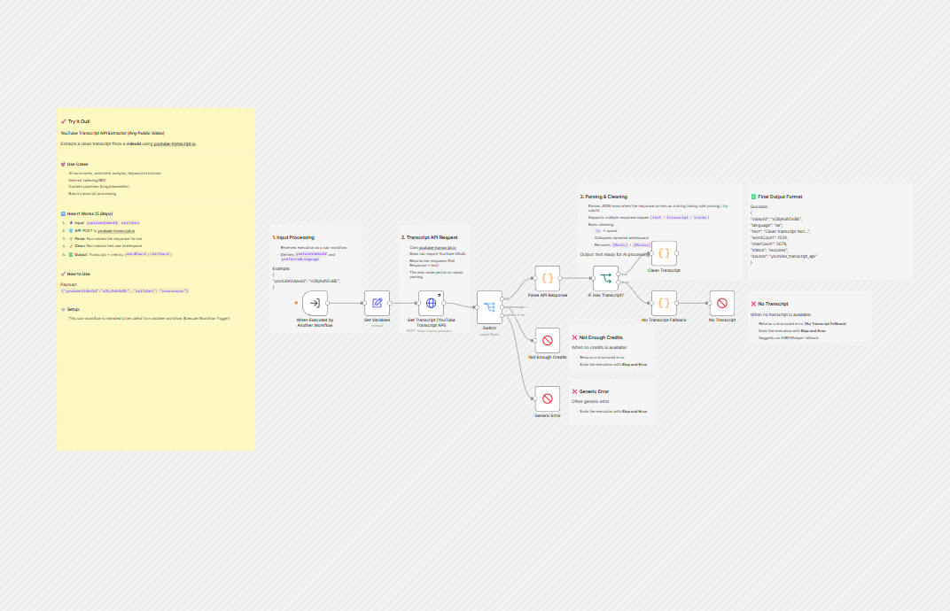

What is added to the template
- Input – youtubeVideoId - Taken the unique number from the youtube (example) xObjAdhDxBE
- API key token – Generated API key token for youtube-transcript.io
- Added a subworkflow Set Edit fields after when executed by another workflow and added 2 fields to provide input for youtubeVideoId and API key and validated output
- 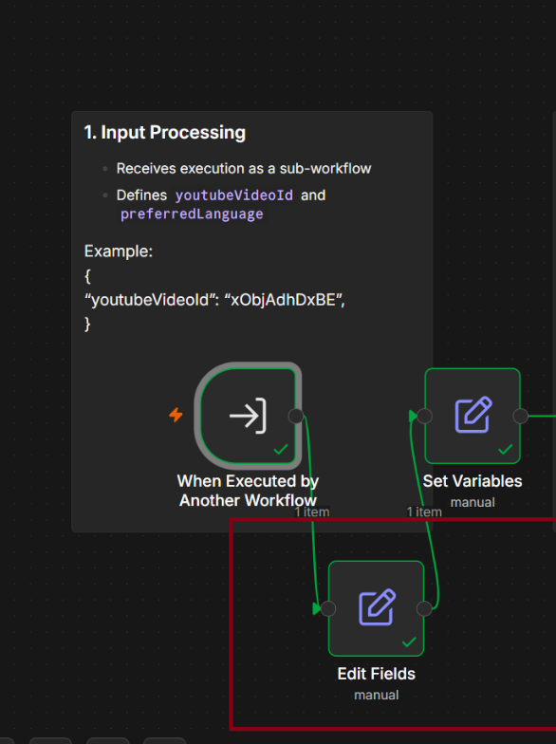
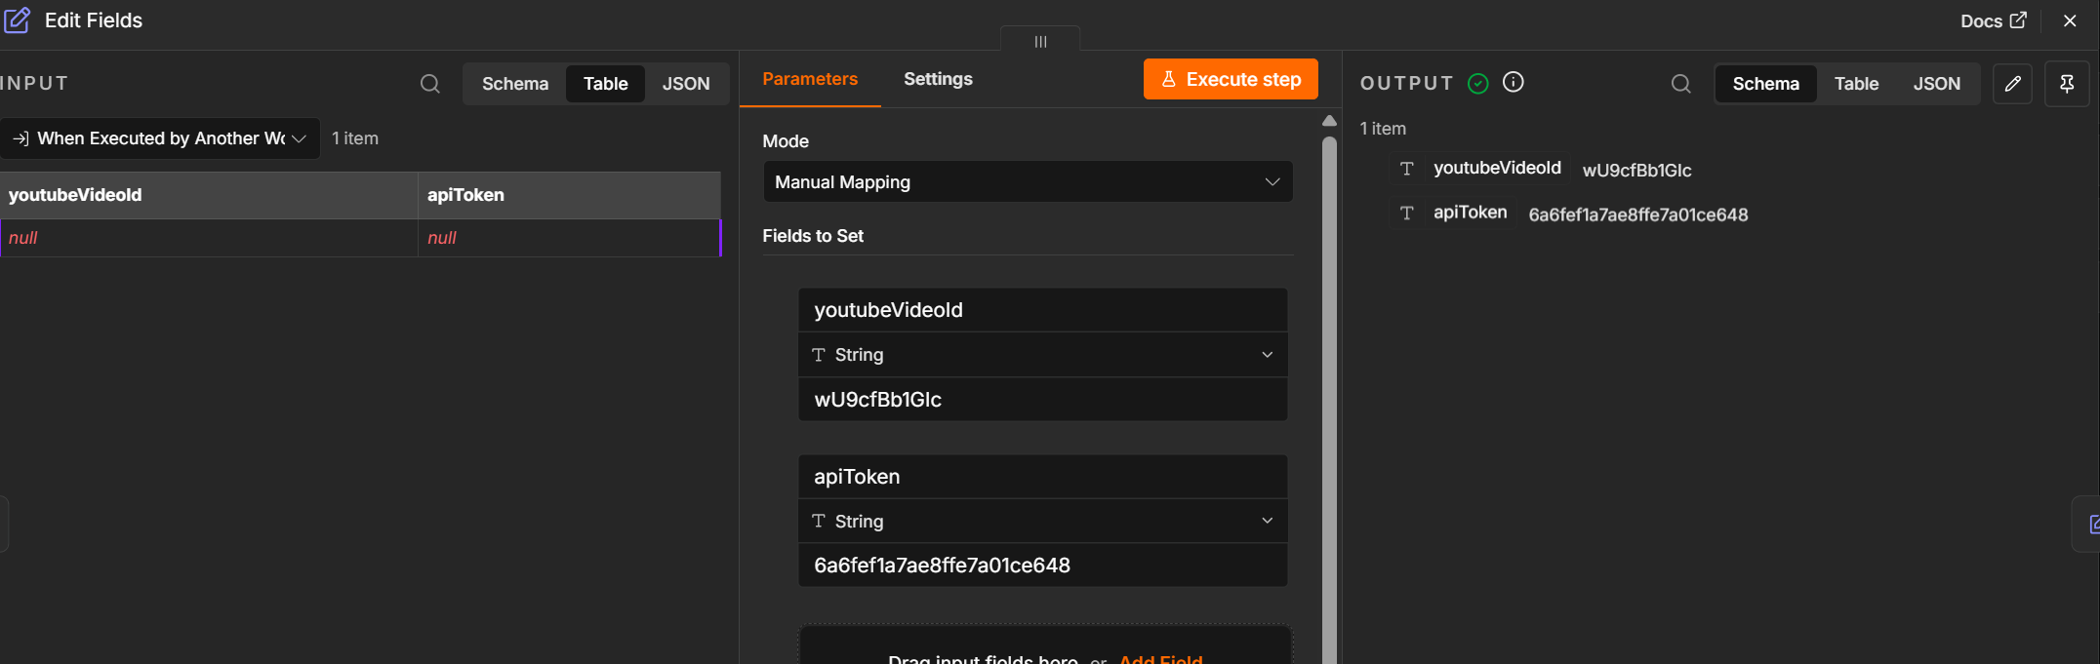
- Added convert to File workflow post clean transcript and converted the output to html
Positive Test case Screenshot
Input - youtubeVideoId - xObjAdhDxBE

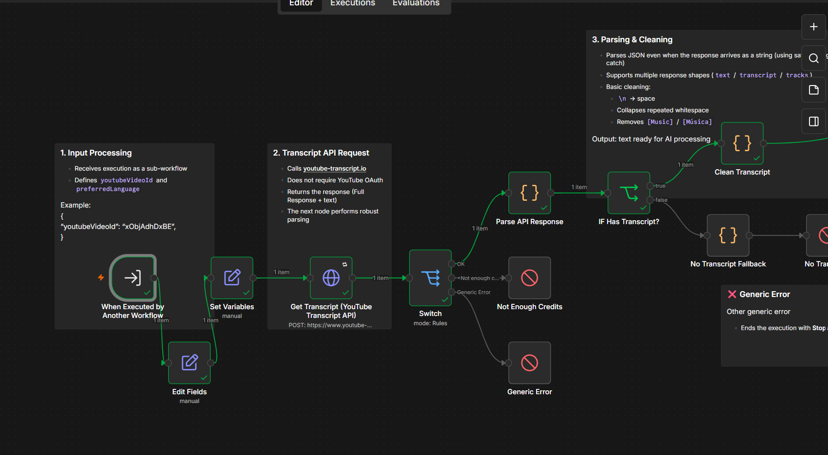

Output file
Scenario #2 - Validated with a video spoken in Tamil.
Input – youtubeVideoId - l6USm7uJa_g
Output File

Error scenario tested by giving wrong youtube ID
